# 11040A Neural Networks

**Assignment 4**

**Deadline: June 12, 2025 24:00**

1. Summarize the key idea of the BP algorithm briefly.
2. Consider an １-M-1 multi-layer perceptron (MLP) whose input-output are denoted by  *t*=1,…,*N* and the activation functions are  for hidden layer and  for output layer.
3. Suppose there is teacher signal, , corresponding the input . The learning rate is $μ$. The loss function is defined as:



**(1)** Derive the backpropagation (BP) training algorithm and describe your derivation process. During your derivation, you should include the value of the parameters below:

$W_{1}$: the set of $ω$ of hidden layer

$b_{1}$: the set of bias of hidden layer

$W_{2}$: the set of $ω$ of output layer

$b_{2}$: the set of bias of output layer

$Z$: the set of outputs of the hidden layer (after passing through the activation function $f_{1}$)

$y(t)$: the output of the MLP of $t-th$ input $x\left(t\right)$

$δ^{1}$: the set of $δ$ of hidden layer

$δ^{2}$: the set of $δ$ of output layer

$ΔW_{1}$: the set of $μ\frac{∂E}{∂ω}$ of hidden layer

$Δb_{1}$: the set of $μ\frac{∂E}{∂b}$ of hidden layer

$ΔW_{2}$: the set of $μ\frac{∂E}{∂ω}$ of output layer

$Δb_{2}$: the set of $μ\frac{∂E}{∂b}$ of output layer

**(2)** How many “ $δ$”s are there in this MLP?

1. Change the activation function for the hidden layer to $f_{1}\left(x\right)=ReLU\left(x\right)$. Train the MLP using the BP algorithm in the case of $M = 2$, $N = 1$, $x\left(1\right)=0.7$, $d\left(1\right)=0.68$, and learning rate $μ= 0.2$. Refer to and fill out the following table.

*If you calculate this problem through programming, please attach your code.

|  |  |  |  |  |  |  |  |  |
| --- | --- | --- | --- | --- | --- | --- | --- | --- |
| t | W1/b1 | W2/b2 | Z | y(1) |  |  |  |  |
| 0 | [[0.3 -0.3]] /[0.0 0.0] | [[-0.1] [0.1]] / [0.0] | [0.21 0] | [-0.021] | [-0.07 0.0] | [0.701] | [[-0.01 0.0]] / [-0.014 0.0] | [[0.029] [0.0]] / [0.14] |
| 1 | [[0.29 -0.3]] / [-0.014 0.0] | [[-0.071] [0.1]] / [0.14] |  |  |  |  |  |  |
| 2 |  |  |  |  |  |  |  |  |
| 3 |  |  |  |  |  |  |  |  |
| … | … | … | … | … | … | … | … | … |

**Hint: s**

If you find this question is quite complex or are still confused about the BP algorithm, you may review what you have learned:

**Chapter 3: Neural Networks –Training; 3.2 BP Training Algorithm I**

We also provide the reference, which you can find in the references section of the course page:

**Hints for Backpropagation**

But please notice that:

(1) There are differences in some symbols between the course PPT and the reference.

(2) Each $δ$ in the reference corresponds to the loss $C^{t}$ of one data point, while each $δ$ in this question corresponds to the total loss $E$ of the entire batch of data. Therefore, if you refer to the reference, for each $ω$ and $b$, you still need one more step to get the final result:

$$∇_{ω,b}E=∇_{ω,b}L\left(θ\right)=\frac{1}{N}\sum_{t=1}^{N}{∇_{ω,b}C^{t}\left(θ\right)}$$

(3) In the course PPT, when representing the value of $δ$, it excluded “ $–$” from $δ$ when calculating this part: $\frac{∂E}{∂y_{k}\left(t\right)}$ (The $\frac{∂C^{t}}{∂y_{m}^{t}}$ part of $δ$ in reference). Therefore, the value of $δ$ in the course PPT is opposite to the value of $δ$ in the reference. For this question, both expressions will be considered correct. (Question (b) take the expression of the course PPT as the example.)

**Programming part**

Please write a report on the following questions and send your report and source code to TA (Remember to pack them into a *.zip file). If you have any questions, feel free to contact the TA.

Note: to have a better understanding of BP, in this assignment, deep learning frameworks such as TensorFlow, Torch, Caffe, Theano etc. are **NOT** allowed to use. However, we suggest utilizing them in the next assignment.

We recommend that you use Python and only use the NumPy and Matplotlib libraries.

1. **SYSTEM: A Two-Nested-Spirals Problem**

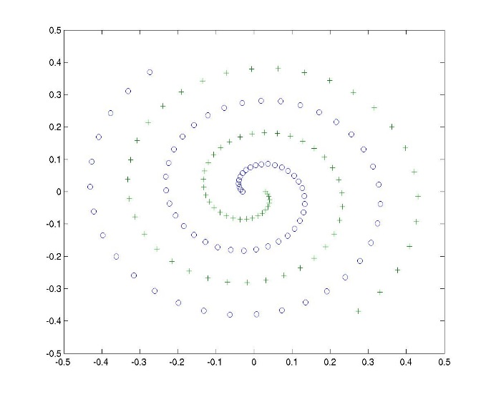Two-Nest-Spirals problem is a well-known classification benchmark problem. It contains two nested spirals, ‘o’ and ‘+’, as shown in figure. The task is to separate the two nested spirals.

1. **Purpose: Separating the Two Classes Using Neural Network Classifier**
   1. Write a program to generate the data set.
   2. Design a neural network classifier.
   3. Define a loss function.
   4. Implement BP algorithm and train the neural network. (Bonus: implement mini-batch, Momentum or other variants of BP)
      1. Discuss what difficulties you encountered and how they were resolved;
      2. You may show the error curve for training data.
   5. After training the neural network, show in a figure (decision boundary) how well the trained neural network can separate the two spirals. (generalization ability)

Please write a report. The report should include your code & results and the explanation of the code.

(You can submit your programming files along with your report. Or you can organize your program into a markdown file or a Jupiter Notebook file as a report and submit it.)